Magnetic Car puzzle  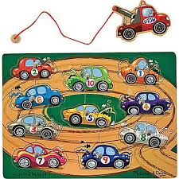  Basic Level  Ages: Pre-k through- 4th grade | Pieces included in visuals  Rules for game  - Place all the pieces to the game on the table  - With a peer and student have them take turns putting the pieces in the puzzle  - Have them label what number and color car they put in the puzzle using the “I put the ____ ____ car in the puzzle”  - Play until all the pieces are back in the puzzle  Additional Tips and Ideas  - Have peers ask the student “What number car do you have?”  - Have the student ask “I want ___ please”  - Roll a dice and have the students try and catch that number car they roll  - Have peers ask for a certain colored car or certain number

